Checking report
Red Marked is missing.
Highlighted with yellow needs to be changed
Reports
- Diocese vices choir registration made year wise. Parish Name and Diocese name, Within india outside india (select finalc year default current start from current 2023) Done
- Payment collected Shopping cart / Offline Office/ Online transfer to office (admin select payment type based on type report) control add filter remain

Parish: Change Name as Manage Parish (icon on dashbaord) Done
Should display the current parish list (list of existing paris and search)
Should not enter duplicate entry. (https://choirdsmc.snehait.com/Frontfiles/choir) search Done

Choir Registration
- Front Form: When all fiends are enterned and submit button is clicked below page is displayed
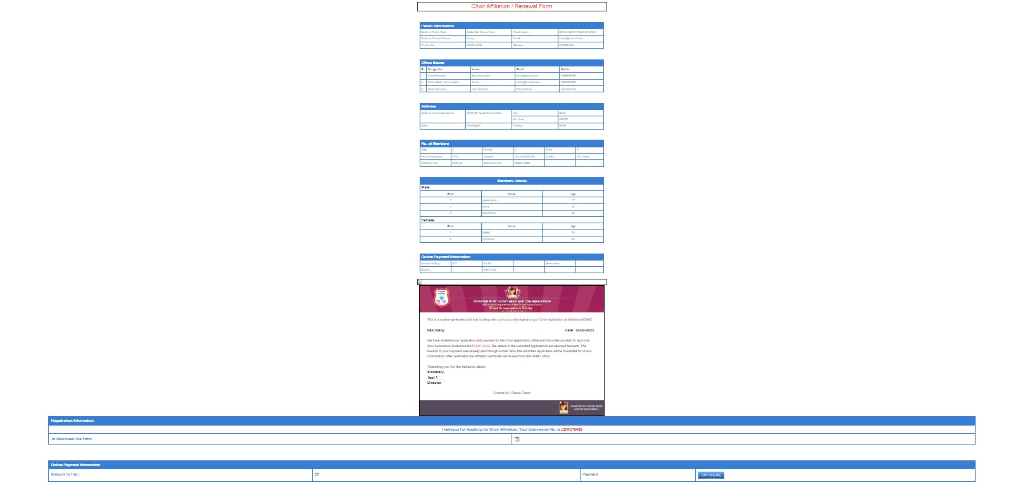
- Pay Online takes time in loading, should have some option as please wait you are redirected to paymentdone

Echo remove from email template when form is submit send email with attachemrnt (only show payment page)
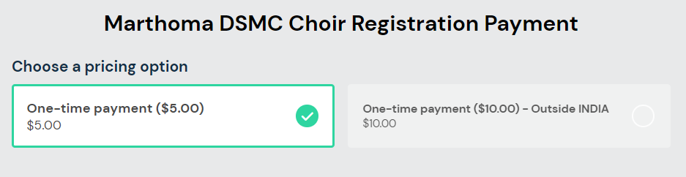

No option to select second payment option should be avaliable.
- Payment does not show parish name

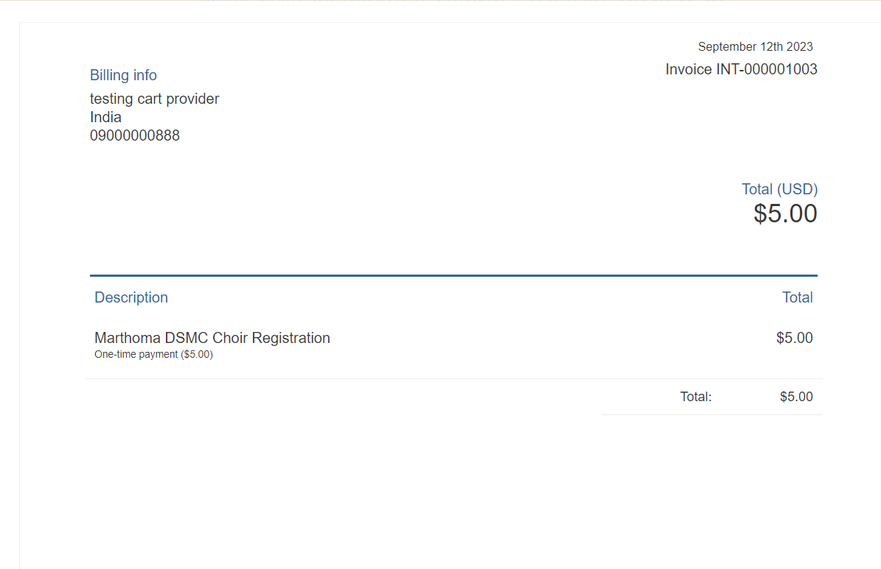
- On successful payment it should return to choir form and display registration No with a message as payment successful your submission no is xxxxx

Admin Section

- Payment approval: Mail of approval page not working Blank screen
Example Edited DSMC10484 and approved, But new entry in vicar approval is found (
DSMC10485) in Vicar Approval. Same entry should move to vicar approval
- Vicar Approved then its blank. Vicar approval is normally done online using the link send over email
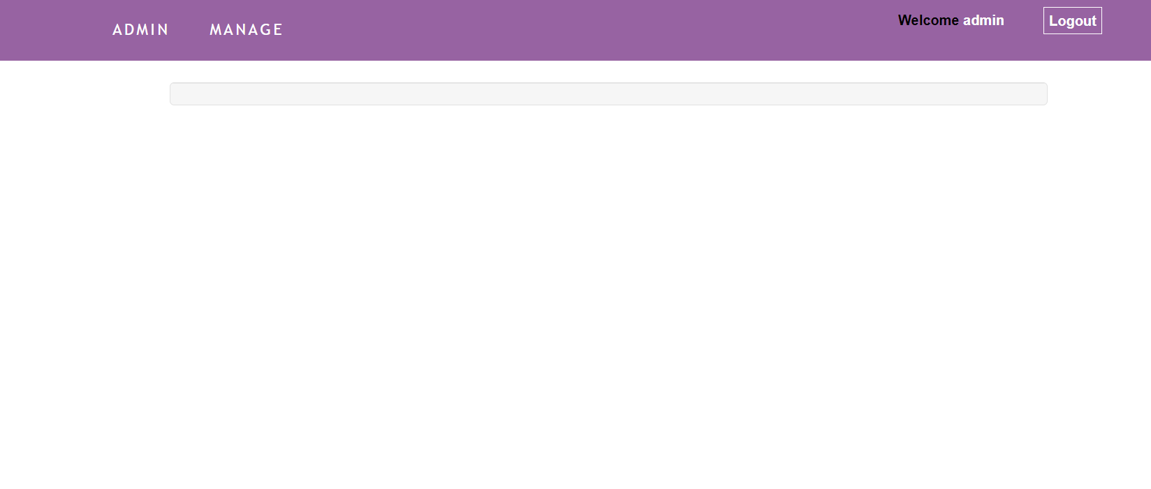
- After director approval above page is displayed, plese check
- DSMC10485 unable to find after director Approval. It should be avaliable at final approval

